Suci Dian Hayati, Ibnul Qayim, Rika Raffiudin, and Miftahudin Miftahudin. Variety of plants and nest site preference: Traditional knowledge of *sunggau* for attracting *Apis dorsata* in Indonesia. Ecosphere.

**Appendix S2.**

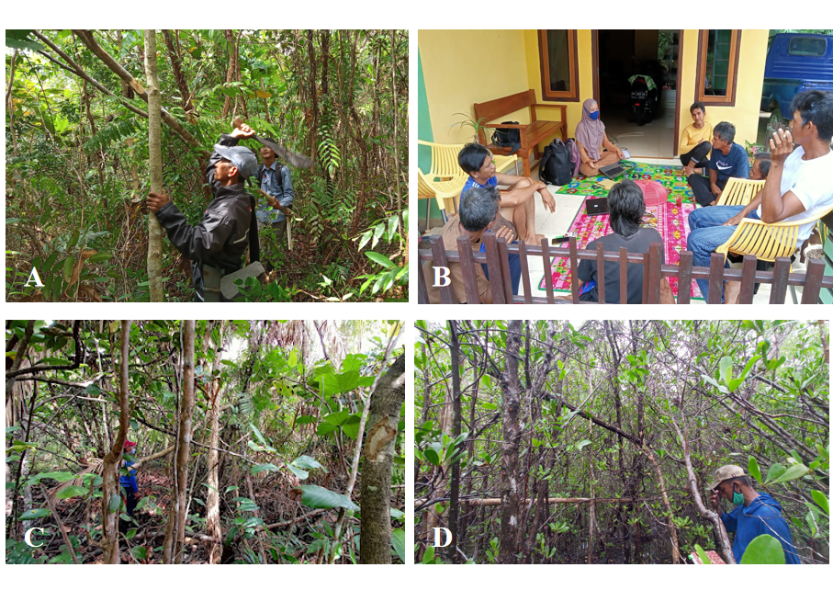

**Figure S1.** Field observation and interviewed with bee farmers: (A). Bee farmers at Perpat; (B). Tanjung Rusa; (C) and (D). Bee farmers at Kembiri.

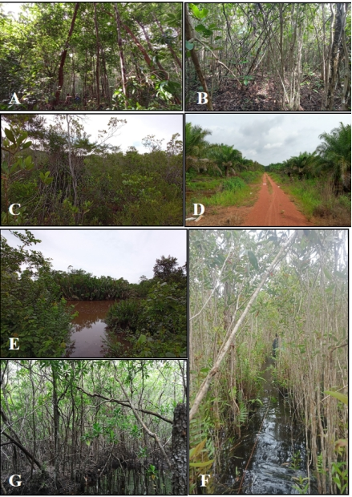

**Figure S2.** Three ecosystem types of sunggau site observed in this study; 1. Terrestrial ecosystems consisted of (A) primary heath forest (*rimba*), (B) secondary heath forest (*bebak*), (C) open degraded heath forest (*padang kerangas*), and (D) oil palm plantation; 2. (E) Riparian river ecosystem; and 3. Wetland ecosystems consisted of (F) swamp (*danau*) and (G) mangrove.

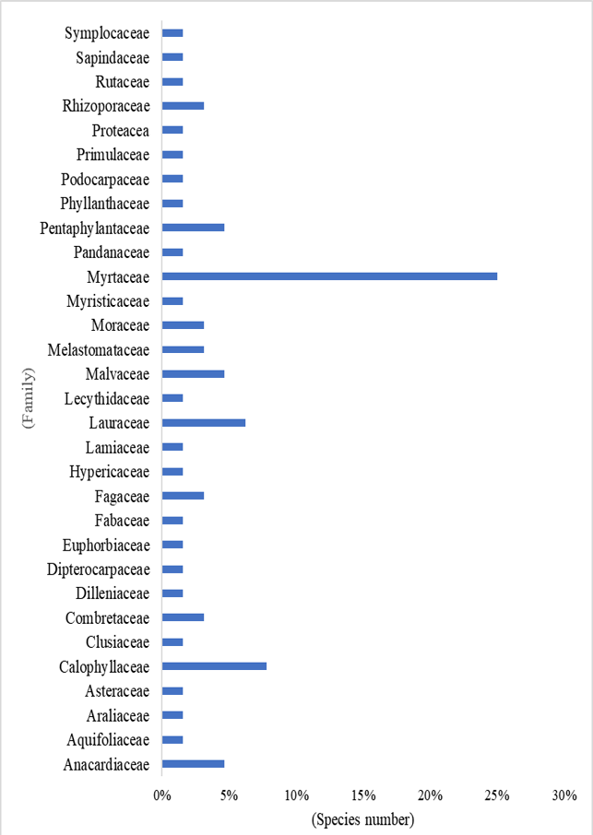

**Figure S3.** Sixty species in 31 families of plants were used as *sunggau* by bee farmers in Perpat, Kembiri, and Tanjung Rusa villages. Myrtaceae were the most common families used as *sunggau*.

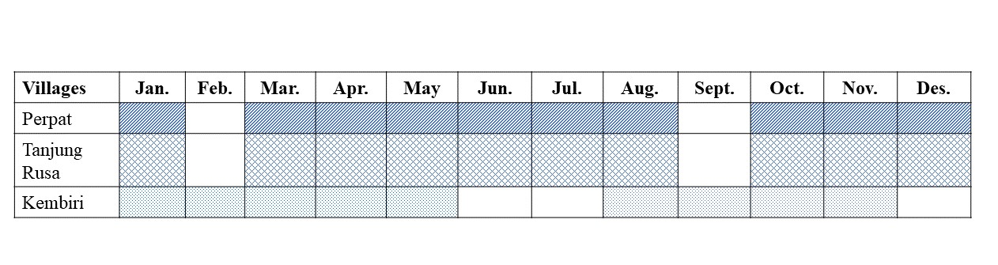

**Figure S4.** Blooming seasons timeline (line patern) in three study areas through 2020, based on bee farmer interviews.